Interacting with the Deployed Alarm Clock Smart Contract

* Code out the Alarm Clock Smart Contract called Alarm. Sol

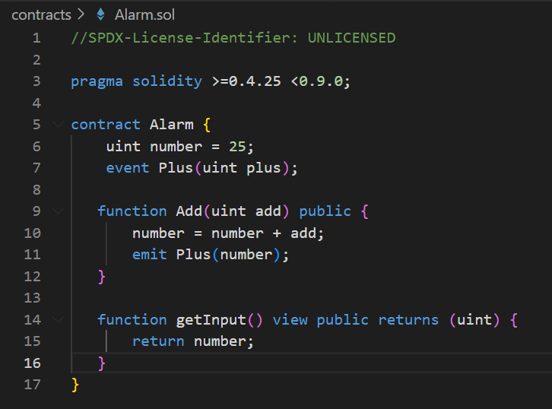

* With Hardhat, Test the Alarm Clock Smart Contract on the Public Blockchain (For Testing only)
  + Write the Deploy Script

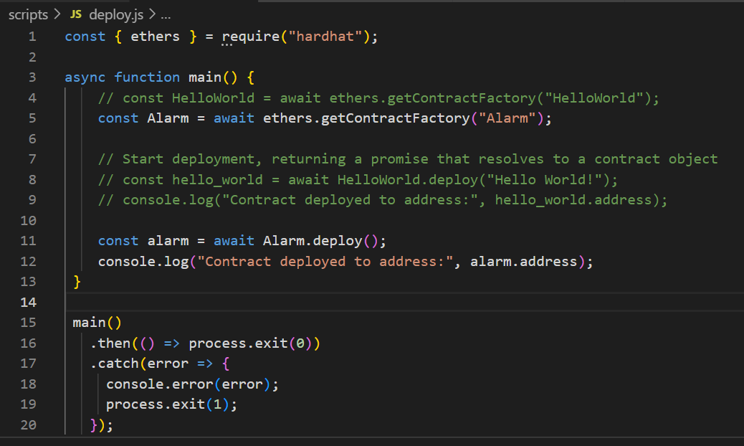

* + Deploy the Smart Contract



* + Interact with the Smart Contract

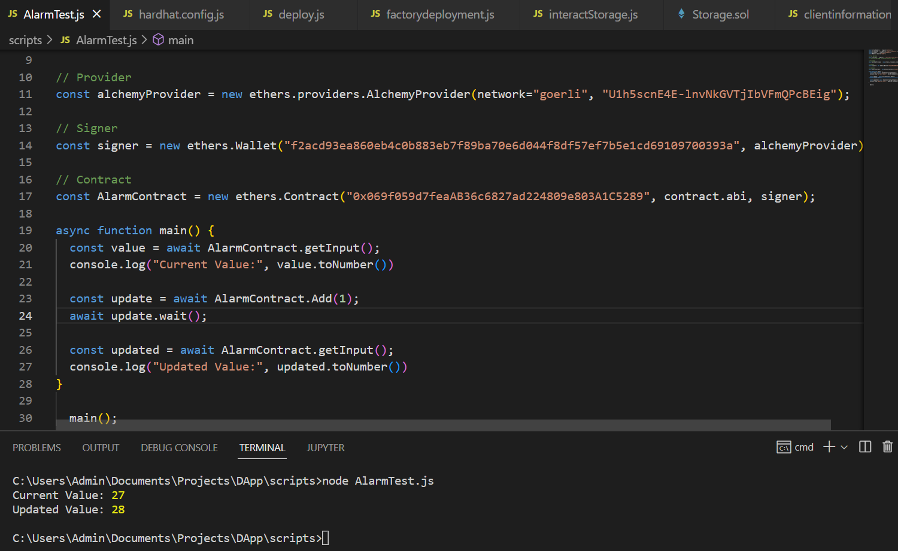

* Alternatively, you could also Test the Alarm Clock Smart Contract on Remix (Optional)(For Testing only)

